EXPERIMENT NO :1

**Getting Started with EXCEL** **: Creation of spread sheets, Insertion of rows and columns , Drag and fill use of aggregate functions.**

**1. Creating spread sheets:**

* **Open Excel** : Launch Microsoft Excel on your computer.
* **New spread sheet**: You can click on the file and them new to create new spread sheet. you can also use template if you prefer .
* **Enter data**: Click on cell and start typing to enter data press enter or Tab to move the next line.

**2. Inserting Rows and Columns**

* **lnserting rows :** Right click on the row number and select “insert” this adds new row above and select the row
* **Insert columns :** Right click on the column number and select “insert” this adds new column left of the select the column. Shortcut keys alternatively use ctrl++ to insert rows and columns.

**3. Drag and fill**

* **Use autofill handle:** enter data in a cell or series of cells then have over the bottom right corner of the cell or cell range until you see small square
* **Drag to fill:** click on and the fill handle across or down and the cell where you want to replicate or extend the data.
* **Auto complete data series:** Excel can auto complete a series like dates, number and even some custom lists.

**4. Using aggregate functions**

* **Basic functions:** Familiarize yourself with basic functions like SUM, AVERAGE, MIN, MAX, COUNT.
* **Formula bar:** To use function click on cell and type in the formula bar for example(=SUM(A1:A10)) add up the value from A1 to A10.
* **Function wizard:** Use the insert function wizard for more complex functions. You can also search for functions and get step by step guidance on how to use them.

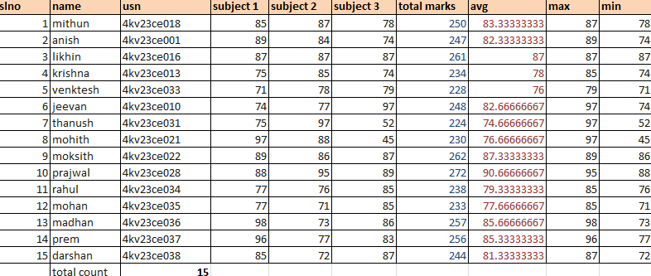

Fig 1.1 Student information

**EXPERIMENT NO :2**

**Working with data : Implementing data, data entry, manipulation, sorting & filtering**

**1.Importing data into Excel**

* **From text files :** Go to data> get external data>from text; Browse for text file(CSV,TXT) and follow the import wizard to import the data into EXCEL
* **From other source :** EXCEL allows importing from various source like other excel files, databases (SQL, Access) web pages. Use data> get external data and select the appropriate source.
* **Copy-paste method :** You can also copy data from other source and paste it directly into an Excel spreadsheet.

**2.Data entry and Manipulation**

* **Data entry :** click on a cell and start typing to enter data, Use tab to move horizontally and enter data in a cell.
* **File handle :** Use the cell fill handle (small square at the bottom-right corner of the cell) to drag and replicate data or to fill a series.
* **Formulas** : Use formulas for calculating and data manipulation start formulas with an equal sign(=) followed by your calculation (eg : =A2+B2)
* **Flash fill :** excel flash fill feature (data>flash fill) can automatically fill in data in data based on a pattern you provide.

**3. Sorting data**

* **Basic sorting :** Select the data range or column you want to sort then go to data>sort. Choose to sort by specific column and select sorting order(Ascending and descending)
* **Custom sort :** For more complex sorting use the custom sorting option where you can sort by multiple columns and define specific sorting criteria for each column.

**4.Filtering Data**

* **Applying filters :** click on data > filters this will add drop down arrows in the header row of your data set. Click these arrows to filter data based on values, text, data or use custom criteria.
* **Advanced filtering :** For more complex filtering criteria use the advanced filter option this allows for setting up multiple criteria and you can also copy filtered data to another location.
* 

Fig 2.1 Importing Data

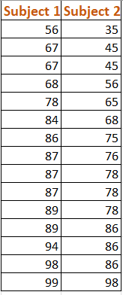

Fig 2.2 Sorting Data

**Experiment:3**

**Working with Data: Data Validation, PivotTables & Pivot Charts.**

**1. Data Validation**

Data Validation in Excel is used to control the type of data or the values that users can enter into a cell.

**How to Use Data Validation:**

* **Select the Cells:** First, select the cells where you want to apply data validation.
* **Set Validation Criteria:** Go to Data > Data Validation. In the Data Validation dialog box, under the 'Settings' tab, you can specify the criteria. For example, you can choose to allow only:
  + - Whole numbers or decimal in a specific range.
    - Dates within a specific range.
    - A list of values (entered manually or referenced from a range on the sheet).
    - Text of a specific length.
* **Input Message and Error Alert:** Optionally, you can provide an input message that appears when the cell is selected, and an error message that appears when someone enters invalid data.

**2. Pivot Tables**

Pivot Tables are one of Excel's most powerful features, used to quickly summarize large amounts of data.

**Creating a Pivot Table:**

* **Select Your Data:** Click on any single cell in a data set.
* **Insert Pivot Table:** Go to Insert > PivotTable. Excel will automatically select the data for the PivotTable.
* **Choose Location:** Decide where you want the PivotTable report to be placed.
* **Arrange Fields:** Drag and drop fields from your dataset into the 'Row Labels', 'Column Labels', 'Values', and 'Filters' areas.
* **Customize and Analyse:** Use the PivotTable Field List to arrange your data, apply filters, and make any adjustments to get the view you need.

**3. Pivot Charts**

Pivot Charts are visual representations of Pivot Table data and are useful in making data more understandable.

**Creating a Pivot Chart:**

* **Create a Pivot Table:** You need a Pivot Table as the basis for a Pivot Chart.
* **Insert Pivot Chart:** With the Pivot Table active, go to Insert > Charts > PivotChart.
* **Choose Chart Type:** Select the type of chart that best fits your data (like Column, Line, Pie, Bar, etc.).
* **Customize the Chart:** After the chart is created, you can customize it by changing its style, layout, and format. You can also filter the chart data using the field buttons on the chart.

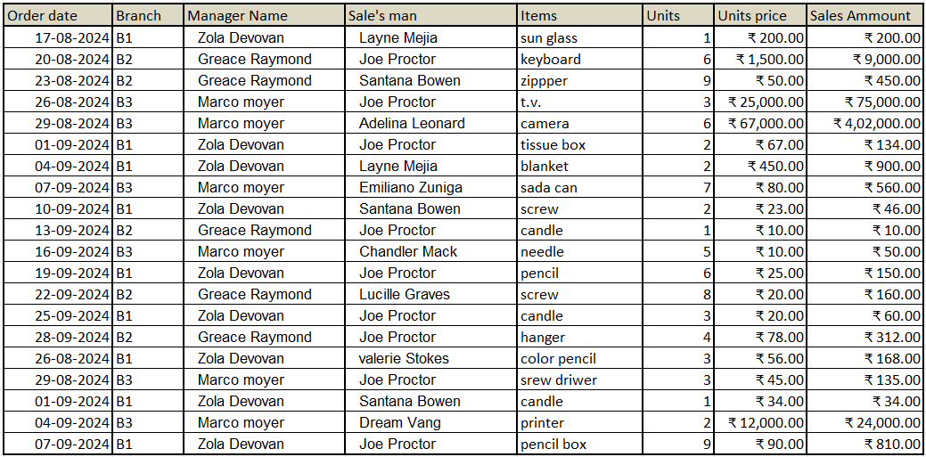

Fig 3.1 sale’s details

Fig 3.2 pivot chart

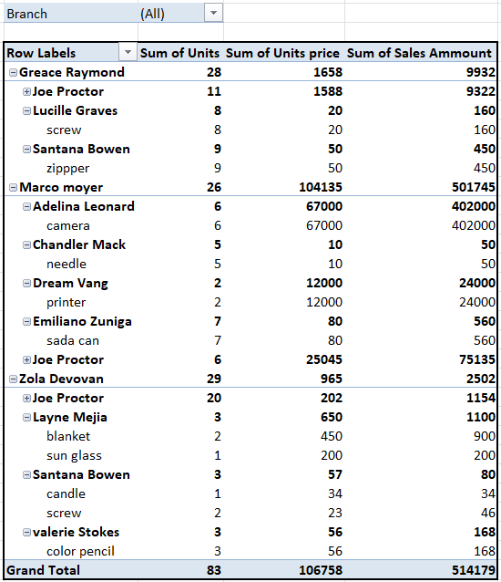

Fig 3.3 pivot table

Experiment: 4

**Data Analysis Process: Conditional Formatting, What-If Analysis, Data Tables, Charts & Graphs.**

**1. Conditional Formatting**

Conditional Formatting in Excel allows you to automatically format cells based on their values, making it easier to visualize data trends and exceptions.

* **How to Use Conditional Formatting:**
* **Select the Data:** Highlight the cells or range you want to format.
* **Apply Conditional Formatting:** Go to Home > Conditional Formatting. Here, you can choose from several options:
* **Highlight Cell Rules:** For example, highlighting cells that are greater than a certain value.
* **Top/Bottom Rules:** Such as highlighting the top 10%.
* **Data Bars or Colour Scales:** These add a visual element to your cells, reflecting the value's magnitude.
* **Icon Sets:** Icons that vary based on the cell value.
* **Create Custom Rules:** Use New Rule for more specific or complex criteria.

**2. What-If Analysis**

What-If Analysis tools in Excel allow you to experiment with your data and analyse different scenarios.

**Types of What-If Analysis Tools:**

* **Goal Seek:** Adjusts a value in one cell to achieve a desired result in another cell. Useful for backward calculations. Found under Data > What-If Analysis > Goal Seek.
* **Data Tables:** Provides a way to view the results of changing one or two variables in your formulas. Particularly useful for sensitivity analysis.
* **Scenario Manager:** Lets you create and save different groups of input values and switch between these scenarios to view different results.

**3. Data Tables**

Data Tables are part of the What-If Analysis tools and are used for systematic analysis of various outcomes based on changing input values.

**Creating a Data Table:**

* **Set Up Your Base Data:** You should have a model or formula set up that you want to analyse.
* **Create the Data Table:** Enter the range of values for the input variables in a row or column near your model. Go to Data > What-If Analysis > Data Table: Specify the row or column input cell and Excel will calculate the model for each input value.

**4. Charts & Graphs**

Charts and Graphs are essential for visualizing data, making it easier to understand and communicate.

**Creating Charts and Graphs:**

* **Select Your Data:** Highlight the data that you want to include in the chart.
* **Choose Chart Type:** Go to Insert > Charts. Select the type of chart that best represents your data (Column, Line, Pie, Bar, etc.).
* **Customize Your Chart:** Add titles, change the chart style, and adjust the layout for clarity and better presentation.

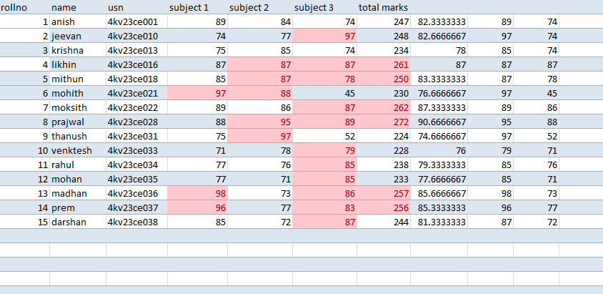

Fig 4.1 Conditional formatting

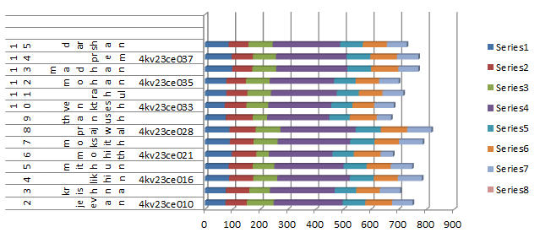

Fig 4.2 bar graph

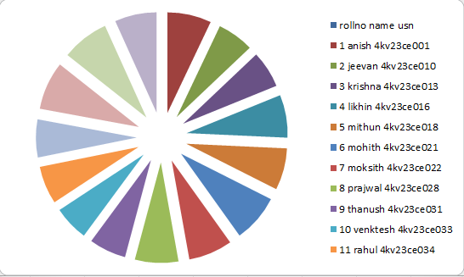

Fig 4.3 Pie Chart

**Experiment: 5**

**Cleaning Data with Text Functions: use of UPPER and LOWER, TRIM function, Concatenate.**

**1. UPPER Function:**

This function converts all letters in a text string to uppercase. It's useful for standardizing text data, such as names or titles.

**Syntax:** =UPPER(text)

**Example:** If cell A1 has the text "excel Data", =UPPER(A1) will return "EXCEL DATA".

**2.LOWER Function:**

This function converts all letters a text string to lowercase. It's used for creating uniformity, especially when data comes from different sources.

**Syntax:** =LOWER(text)

**Example:** If cell A1 has the text "Excel DATA", =LOWER(A1) will return "excel data".

**3.TRIM Function:**

The TRIM function removes all spaces from text except for single spaces between words. It's useful for cleaning up data that contains irregular spacing, especially data imported from other sources.

**Syntax:** =TRIM(text)

**Example:** If cell A1 has the text " Excel Data ", =TRIM(A1) will return "Excel Data" (with single spacing).

**CONCATENATE Function:**

This function combines two or more text strings into one string. It's useful for merging data from different columns.

**Syntax:** =CONCATENATE(text1, [text2], ...)

**Example:** If cell A1 has "Excel" and cell B1 has "Data", =CONCATENATE(A1, " ", B1) will return "Excel Data".

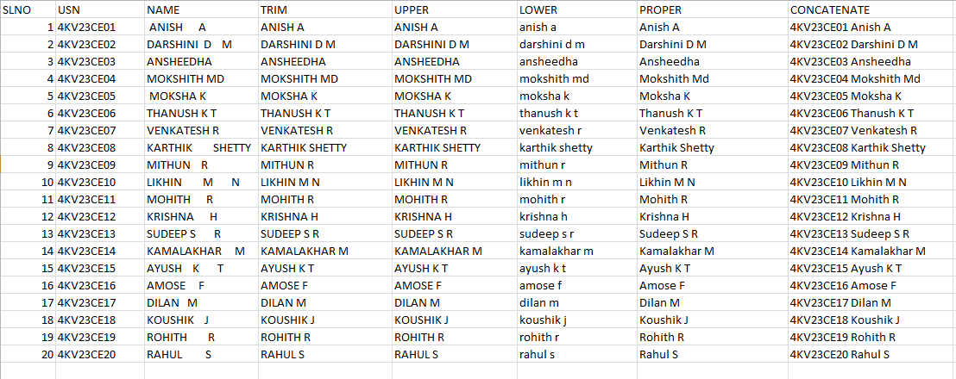

Fig 5.1 using text functions

**Experiment: 6**

**Cleaning Data Containing Date and Time Values: use of DATEVALUE function, DATEADD and DATEDIF, TIMEVALUE Functions.**

**1.DATEVALUE Function:**

The DATEVALUE function in Excel is used to convert a date in the form of text to a date serial number that Excel recognizes as a date. The syntax is DATEVALUE(date_text).This is particularly useful when you're dealing with dates that Excel doesn't automatically recognize as date formats.

**Example:** =DATEVALUE("2024-01-31") would return the serial number for January 31, 2024.

**2.DATEADD Function:**

There isn't a DATEADD function in Excel. However, you can perform similar operations using other functions like EDATE for adding months to a date or using simple addition for adding days. For adding years, months, or days to a date, you can use the formula DATE(year, month, day) + number_of_days.

**Example:** =DATE(2024, 1, 31) + 30 would add 30 days to January 31, 2024.

**3.DATEDIF Function:**

The DATEDIF function calculates the difference between two dates. The syntax is DATEDIF(start_date , end_date , "unit"), where "unit" is a code that specifies the time unit to use (e.g., "Y" for years, "M" for months, "D" for days).

**Example:** =DATEDIF("2024-01-01", "2024-01-31", "D") would calculate the number of days between January 1, 2024, and January 31, 2024.

**4.TIMEVALUE Function:**

The TIMEVALUE function converts a time in the form of text to a decimal number representing the time in Excel. The syntax is TIMEVALUE(time_text).

**Example:** =TIMEVALUE("13:45:00") would return the decimal number representing 1:45 PM in Excel.

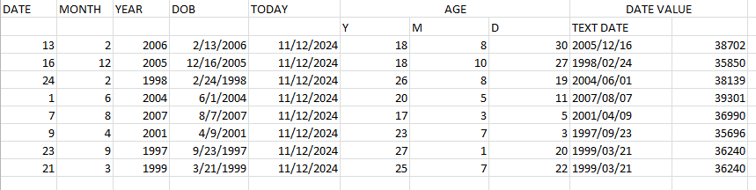

Fig 6.1 using DATEVALUE, DATEVALUE, DATEDIF function

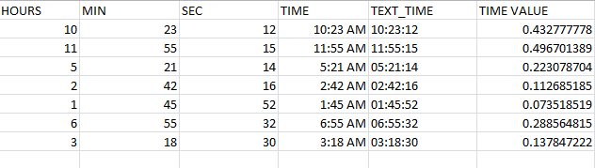

Fig 6.2 using TIMEVALLUE function

Experiment :7

**Conditional Formating : formatting , parsing and highlighting data in spread sheet during data analytics**

**Basics of Conditional Formatting**

**What it Does:** Conditional formatting changes the appearance of cells in a spread sheet based on specific conditions or criteria. For example, you can set rules to change the background colour, font colour, or apply other formatting styles to cells if they meet certain conditions.

**Criteria:** You can base conditions on a variety of criteria, such as specific values, text, dates, the outcome of formulas, or even comparison with other cells.

**Common Use Cases**

**Highlighting Cells:** Changing the background or text color of cells based on their values is one of the most common uses. For example, highlighting cells in red if they contain values below a certain threshold.

**Data Bars or Colour Scales:** These visual aids fill cells with a gradient or bar, reflecting the cell’s value in comparison to others in the range. Higher values might get a deeper color or longer bar.

**Icon Sets:** Adding icons (like arrows or flags) to cells to represent data categories or value ranges, making it easy to visualize data status or trends.

**Duplicate Values:** Identifying and marking duplicate values within a range to easily spot and remove or analyze them.

**Top/Bottom Values:** Highlighting the top or bottom N values or percentages in a dataset to focus on outliers or significant data points.

**How to Implement Conditional Formatting**

While the exact steps can vary slightly between spread sheet applications (e.g., Microsoft Excel, Google Sheets), the basic process is generally the same:

**Select the Range:** First, select the cells or range of cells you want to apply conditional formatting to.

**Find Conditional Formatting:** Look for the 'Conditional Formatting' option in the menu. In Excel, it's under the 'Home' tab, and in Google Sheets, it's under 'Format'.

**Set the Rule:** Choose the type of rule you want to apply (e.g., greater than, less than, between, equal to, text that contains, date is, etc.). You can also use custom formulas for more complex conditions.

**Choose the Formatting:** Select the formatting style (e.g., colour fill, text colour, data bars) you want to apply when the condition is met.

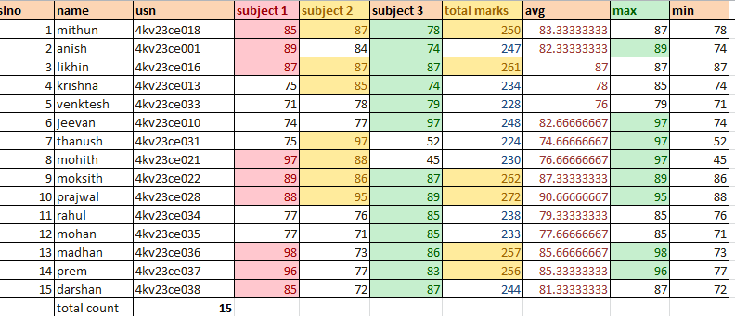

Working with multiple sheets: work with multiple sheets within a work book is crucial for organizing and managing data performs complex calculations and create comphrehensive reports